1. **Which are the top three variables in your model which contribute most towards the probability of a lead getting converted?**

**Answer :-** Top three variableswhich converted most towards the probablity of lead converted are **:-**

* + - 1. Tags_ Closed by Horizzon
      2. Tags_ Lost to EINS

3 Tags_ will revert after reading the email

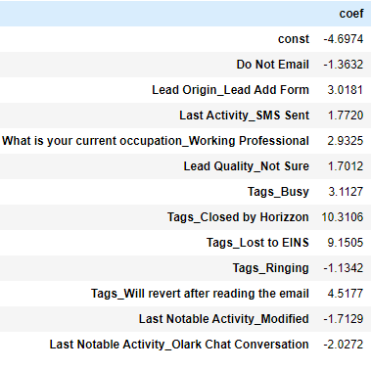

1. **What are the top 3 categorical/dummy variables in the model which should be focused the most on in order to increase the probability of lead conversion?**

**Answer:-** Top 3 categorical/dummy variables in the model the most on in order to increase the probability of lead conversion these are:-

* + - 1. Do not Email

2. Last Notable Activity_ modified

3 Last Notable Activity_ Olark_ chat_ conversation



1. **X Education has a period of 2 months every year during which they hire some interns. The sales team, in particular, has around 10 interns allotted to them. So during this phase, they wish to make the lead conversion more aggressive. So they want almost all of the potential leads (i.e. the customers who have been predicted as 1 by the model) to be converted and hence, want to make phone calls to as much of such people as possible. Suggest a good strategy they should employ at this stage.**

**Answer:-**  The good strategies for leading who have identified as1 by the model is to do follow ups, which means to get back in touch with the leads after their initial call. It can be achieved with phone calls or sending nurturing emails. Also tracking previous conversations to know if the lead is interested in getting converted as a paying customer. Finally, lead nurturing which means sending various kinds of emails to keep the leads interested so as to choose the X Education instead of others. As for example, it can be emails of promos or other offers, such as rebate in interested courses if applied within a certain period.

1. **Similarly, at times, the company reaches its target for a quarter before the deadline. During this time, the company wants the sales team to focus on some new work as well. So during this time, the company’s aim is to not make phone calls unless it’s extremely necessary, i.e. they want to minimize the rate of useless phone calls. Suggest a strategy they should employ at this stage.**

**Answer:-** Leads who have applied for ‘Do Not Email’ already does not needs to be attended again. Also based on the previous chat conversations if the lead is classified as ‘Might be’ or ‘Worst’ then those leads can be ignored. Leads who shared their contact number in the website or through email but either are ‘Busy’ or ‘Ringing’ i.e., not answering to the calls can also be ignored as they are less likely to get converted.